Input | Process | Output
- num 1  - num2 | - Read the two numbers (num1 and num2)  - Check if either number is zero (if so, the other is the HCF)  - If num1<num2  Factor =num1  - Else  Factor =num2  - If num1% factor!=0 or num2% factor != 0  Factor = factor – 1  - Else  - Show “Highest Factor ” | - Highest Common Factor of the two numbers
IPO Chard

Flow Chard
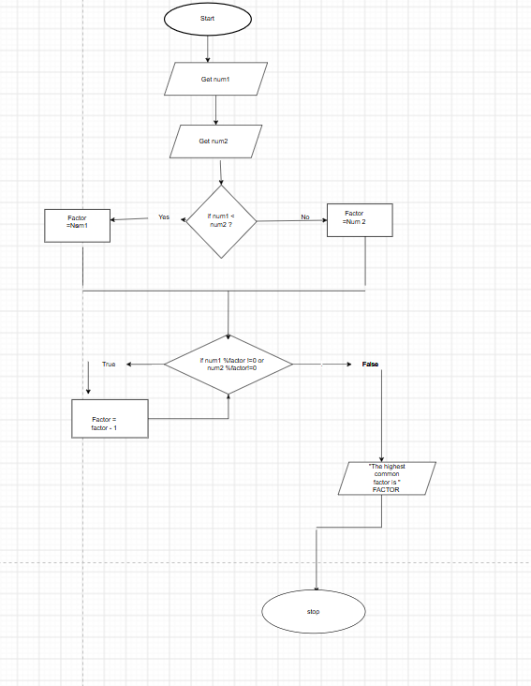

Test cases

